**Project Report**

**Project Title**

**Bankruptcy Prediction**

**Team Leader:**

G . Sandhya Rani 21R11A0597

**Team Members:**

Dhathri 21R11A0545

Hasini 21R11A0518

Pooja 21R11A0501

PSBN Sriya 21R11A0595

N Sai Charan 21R11A0588

MD.Akhbar Ali 21R11A0586

Shivanoor Vignesh 21R11A0597

**Exploratory Data Analysis**

**Import data set**

For importing the dataset and to perform Exploratory Data Analysis we have to import some packages or library which are essential.

* import pandas
* import NumPy
* import seaborn

import matplotlib

**Count of Bankruptcy**

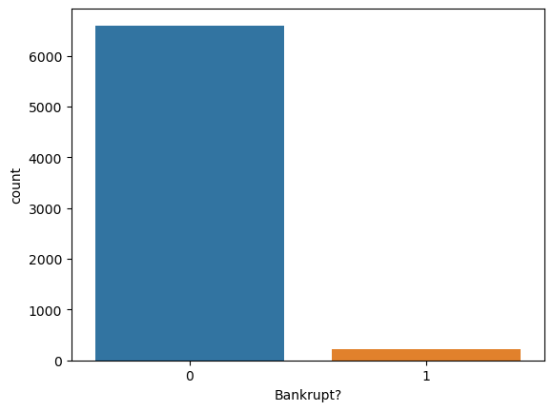

**Observation**

The bar graph illustrates the counts of two distinct categories labeled “0” and “1” under the question “Bankrupt?”. Here are the key observations:

Category “0”:

The count for this category is significantly higher, almost reaching 6000.

This suggests that a large majority of data points fall into category “0”.

Category “1”:

In contrast, the count for this category is just above 0.

The scarcity of data points in category “1” indicates that bankruptcy occurrences are relatively rare within this specific dataset.

**QUICK ASSETS /TOTAL ASSETS DISTRIBUTION**

OPPP0OO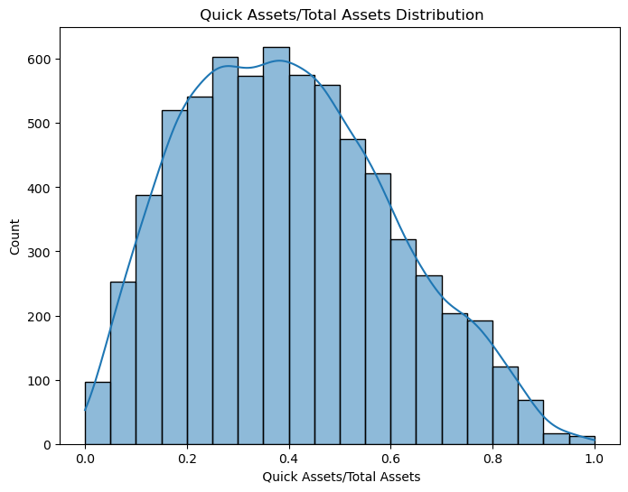

OBSERVATION

From the above bargraph we can say that

* The histogram appears to be **right-skewed**, with a peak around **0.4-0.6**.
* Most entities seem to have a **Quick Assets/Total Assets** ratio in this range.
* Entities with ratios below 0.4 may have relatively low liquidity, potentially facing challenges in meeting immediate financial needs.
* Conversely, those with ratios above 0.6 are likely to have a strong liquidity position.

**Total ASSET TURNOVER DISTRIBUTION**

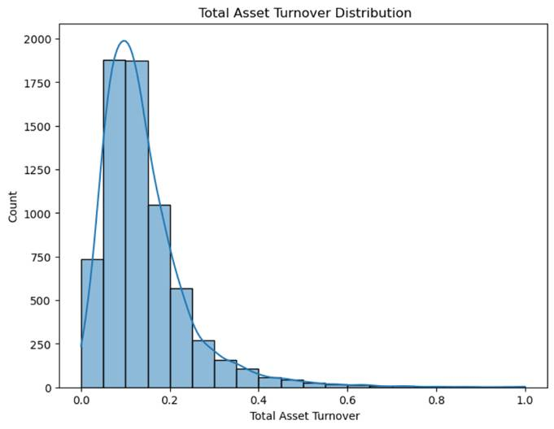

**OBSERVATION**

* The histogram shows a **right-skewed** distribution.
* Most data points are clustered around the range of **0.1 to 0.2**.
* Entities with a **Total Asset Turnover** ratio below 0.1 may not be effectively using their assets to generate revenue.
* Ratios around 0.2 suggest common efficiency levels in asset utilization.

**Dept ratio % Distribution**

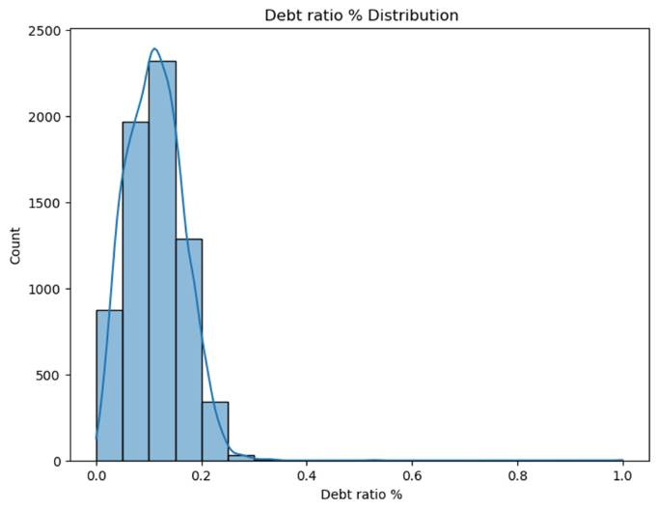

**Observation**

From the above the histogram we can say that :

* The histogram appears to be **right-skewed**, with a peak around **0.1** debt ratio percentage.
* Most data points are clustered between **0.0 and 0.4**.
  + Entities with low debt ratios (around 0.1) are likely less leveraged and have lower financial risk.
  + Instances with high debt ratios are relatively rare within this dataset.

**DEPRECIATION BEFORE INTREST DISTRIBUTION**

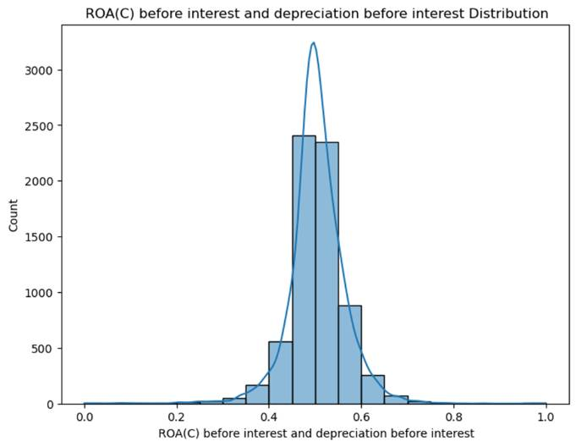

**OBSERVATION**

* The histogram shows a **right-skewed** distribution.
* Most data points are clustered around the value of approximately **0.4**.
* Entities with an ROA© around 0.4 are likely achieving a reasonable balance between asset efficiency and profitability.
* The skewness suggests variations in performance across different companies or industries.

**Operating Expense Rate Distribution**

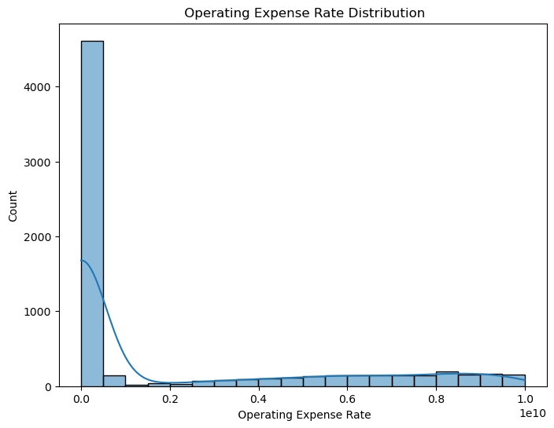

**Observation**

From the above histogram we can say that:

* + The bar graph shows a **right-skewed** distribution.
  + Most data points are clustered at the **lower end** of the operating expense rate.
  + Entities with an operating expense rate close to **0.0** are likely minimizing their expenses effectively.
  + As the rate increases, fewer entities fall into those higher expense categories.

**Different model prediction**

Logistic Regression - Accuracy: 0.9574780058651027

Decision Tree - Accuracy: 0.9516129032258065

Random Forest - Accuracy: 0.9652981427174976

The best model among the provided models is the Random Forest , with an accuracy probability 0.9652981427174976

Based on the provided data and the output from the analysis of "Bankruptcy prediction”

**Transaction 1**

{

"Results": {

"WebServiceOutput0": [

{

"Bankrupt?": 1,

"Net Income to Total Assets": 0.716845343217827,

"Operating Profit Growth Rate": 0.848194994526472,

Operating Profit Rate": 0.998969203197885

"Equity to Long-term Liability": 0.126549487816618,

"Total debt/Total net worth": 0.0212659243655332,

"Net Income to Stockholder's Equity": 0.82789021403512,

"Interest Coverage Ratio (Interest expense to EBIT)": 0.564050112276341,

"Operating Expense Rate": 0.000125696868875964,

"Current Ratio": 0.002258963310566

"Cash Flow to Total Assets": 0.637555395323871,

"Scored Labels": 1,

"Scored Probabilities": 0.519323057306218

}

**Observation**

The value of “Bankrupt?” is **1**, which indicates that the company is classified as potentially bankrupt.

The company’s financial health appears to be precarious, with a high bankruptcy risk (as indicated by the “Bankrupt?” label).

While profitability metrics (net income to total assets, operating profit growth rate, and operating profit rate) are positive, the low equity-to-liability ratio and high debt-to-net-worth ratio raise concerns.

The scored probability of approximately 0.519 indicates uncertainty

**Transaction 2**

{

"Bankrupt?": 1,

"Operating Expense Rate": 0.000289785053728762,

"Research and development expense rate": "0",

"Net Income to Stockholder's Equity": 0.839969268005573,

"Quick Assets/Total Assets": 0.127236002293688,

"Total debt/Total net worth": 0.0125023937843679,

"Operating Expense Rate": 0.000289785053728762,

"Equity to Long-term Liability": 0.120916105834965,

"Net Income to Stockholder's Equity": 0.839969268005573,

"Total debt/Total net worth": 0.0125023937843679,

"Cash Flow to Total Assets": 0.64109998470196,

"Current Ratio": 0.00601620587767277,

"Quick Ratio": 0.00403936682691048

"Operating Expense Rate": 0.000289785053728762,

"Interest Coverage Ratio (Interest expense to EBIT)": 0.570174946412453

"Scored Labels": 0,

"Scored Probabilities": 0.11806796432948005

},

**Observation**

* The **“Bankrupt?”** label is a critical factor. A value of **1** indicates a potentially bankrupt company, which significantly affects the overall probability.
* The low bankruptcy risk (as indicated by the “Bankrupt?” label) is supported by positive metrics such as net income, liquidity ratios, and efficient cost management.
* However, the absence of research and development expenses and the low equity-to-liability ratio in this transaction may raise concerns about innovation and long-term growth prospects.
* The scored probability of approximately 11.81% reflects uncertainty and the need for additional context.
* The scored probability is verry low

**Transaction 3**

{

"Bankrupt?": 1,

"Scored Labels": 0,

"Scored Probabilities": 0.24990627577514649

"Net Income to Total Assets": 0.774669696989803,

"Operating Profit Rate": 0.998857353483229,

"Equity to Long-term Liability": 0.117922319423666,

"Total debt/Total net worth": 0.0212476860084444,

"Net Income to Stockholder's Equity": 0.836774308550174,

"Interest Coverage Ratio (Interest expense to EBIT)": 0.563706076496047,

"Operating Expense Rate": 0.000236129720556318,

"Current Ratio": 0.0115425536893801,

"Quick Ratio": 0.00534756022243655,

"Cash Flow to Total Assets": 0.642764550242219,

}

**Observation**

The **“Bankrupt?”** label is a critical factor. A value of **1** indicates a potentially bankrupt company, which significantly affects the overall probability.

**Profitability Metrics**:

**Net Income to Total Assets**: A high net income relative to total assets (approximately 77.47%) is favorable. It suggests efficient utilization of assets.

**Operating Profit Rate**: The operating profit rate (approximately 99.89%) indicates strong operational performance.

The low bankruptcy risk (as indicated by the “Bankrupt?” label) is supported by positive profitability metrics and efficient cash flow management.

However, the low equity-to-liability ratio warrants further investigation.

The scored probability of approximately 24.99% which lower probability .

**Conclusion**

All three transactions exhibit varying levels of risk, profitability, and financial stability.

Companies should consider improving equity-to-liability ratios, managing debt, and investing in innovation to mitigate bankruptcy risks.

Transaction (0.51): Moderate uncertainty. Companies here exhibit balanced risk profiles, requiring vigilance for financial health monitoring.

Transaction 2 (0.11): Robust financial position. These companies demonstrate strong fundamentals, with minimal bankruptcy risk.

Transaction 3 (0.24): Moderate risk. Investigation into specific metrics driving this probability is essential.

In conclusion, the analysis of the three transactions indicates varying levels of bankruptcy risk and financial health. Companies with higher probabilities should focus on improving key financial ratios and reducing debt to mitigate risk. Those with lower probabilities should continue to maintain strong financial practices. Monitoring and adjusting strategies based on evolving financial indicators are crucial for long-term stability.